**AFRICAN YOUTH FOR CHANGE INITIATIVE**

Michael Twene Osei

Ashesi University

+233547264511

Sikapa447@gmail.com

**PROJECT DESCRIPTION**

The AYCI is a youth-led and youth-focused organization that nurtures young people to be initiators and catalysts of transformative change on the continent and beyond. The AYCI does this by training young leaders through clubs with a curriculum that emphasizes leadership, ethics, entrepreneurship and personal development. Our comprehensive curriculum also provides experiential learning for recruits to practice what they learn from the training.

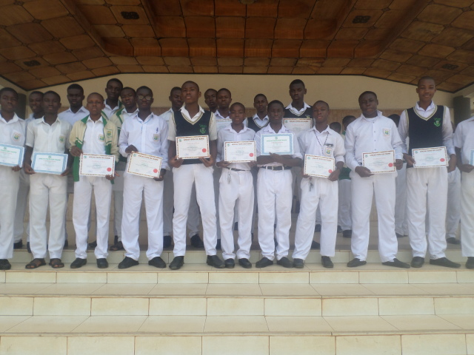*Our young leaders displaying their certificates after a training session. AYCI (ST. James Chapter)*

**MISSION**

To create an exclusive platform for African youth to identify and develop their talents as they utilize them in a cooperative manner, to solve the challenges confronting the continent and our world.

**ACTIVITIES**

* We organize leadership seminars for our young leaders and other interested young people.
* We create opportunities for our young leaders to receive mentorship from people who may be in a field that is of interest to the young leader.
* We expose our young leaders to opportunities and help them apply for those opportunities
* Through our curriculum and experiential learning experience, we train and equip our young leaders with the character, knowledge and skills required to transform the African continent as well as impact the world.
* We carry out civic engagement projects targeted at developing young people.

**CONTACT INFO**

Email: [afroyouth4change@gmail.com](mailto:afroyouth4change@gmail.com)